Project Plan
FoodTrip Search Engine

Table of Contents

Table of Contents ii
Revision History ii
1. Business Requirements 1
1.0 General Information.................................................................................................1
1.1.Purpose, Scope, and Objectives………………………………………………1
1.2.System Overview………………………………………………………………..2
1.3.Contacts………………………………………………………………………….2
1.4.Project References………………………………………………………….…..3
1.5.Relationship to Other Projects…………………………………………………3
1.6.Organizational Interfaces……………………………………………………….4
1.7.Acronyms and Abbreviations…………………………………………………..5
1.8. Background 5
1.9. Business Opportunity 6
1.10.Business Objectives and Success Criteria 6
1.11.Customer or Market Needs 6
1.12.Business Risks 6
2. Vision of the Solution 7
2.1. Vision Statement 7
2.2. Major Features 7
2.3. Assumptions and Dependencies 7
3. Scope and Limitations 7
3.1. Scope of Initial Release 8
3.2. Scope of Subsequent Releases 8
3.3. Limitations and Exclusions 8
4. Business Context 8
4.1. Stakeholder Profiles 8
4.2. Project Priorities 8
4.3. Operating Environment 9
5. Gantt Chart…………………………………………………………………………10
6. Work Breakdown Structure………………………………………………………12
7. Activity List………………………………………………………………………….
12

1.Business Requirements
We are developing an application using a database information of selected restaurants in Makati, an application that determine how search results are displayed. This application is develop to implement and market restaurants by creating an application that can show details and information about the restaurant, price list and most importantly to show its location where the user can easily access on how they can able to get to the restaurant they want.

1.0.General Information

1.1.Project Description
FoodTrip Restaurant Search Engine is an Application where you can easily access restaurant around Metro Manila explore high class restaurant's in different cuisine category and choose a restaurant you want to visit where you can view information, feedback and promotion deals.

Purpose
FoodTrip App is a visual guide to good food and where to find it. Instead of reviewing restaurants, we can recommend great dishes and see what others recommend wherever you go.

Scope
This project aims to provide a user friendly Web Application. An application that can be used to access high class restaurant around metro manila. The user must be a member to avail different promos and discount offered by other restaurant. The user/member may use FoodTrip App to find and review different cuisine and restaurant.

General Objectives
The General Objective of this Application Project is to provide Diner/User's to access location and information about the restaurant around metro manila

Specific Objectives
• To provide hassle free restaurant search around Metro Manila.
• To find desired restaurants the Diner/User wants to visit.
• To show updated restaurant menu and promotions offered by the restaurant's

1.2 System Overview

Software Environment

Programming Languages

- The application will be developed using Java, HTML5, PHP, Mobile framework

Specific Software

- FoodTrip application uses the SQLite Database to store data and is connected to cloud server and Android Studio

Operating System

- The application runs in Android Operating System. Android API level 19 kit Kat

Hardware Environment

- The focus of this project is to apply the use of android phones and the internet for the user for better information about different cuisine and restaurant around metro manila.

Network Requirements

- Internet connection – specifically DSL or Broadband internet or Wi-Fi connections

Application Implementation Priorities

Scheduling
The project team will be using Agile Methodology in scheduling the project. This method will be used so that the application will be developed faster and use the remaining time to adjust the application to the client’s needs. The project time will be divided into three iterations for faster time and better communication with the client. A detailed project schedule is provided at the end of the page.

1.4. Project References

Communication
The project manager will set up meetings with the client for additional requirements and iteration presentations.
Type of communication | Communication Schedule | Typical communication mechanism | Who initiates | Recipient
Project Planning | Start of the Project | Face to face meetings/email | Project Manager | Project Client
Information Management | Sep 26, 2015 | Face to face meetings/email | Project Manager | Project Manager
1st Iteration | Dec 16, 2015 | Face to face meetings/email | Project Team | Project Client
2nd Iteration | Feb 29, 2016 | Face to face meetings/email Presentation | Project Team | Project Client

Risk Management
The project team may encounter risks in the development of this project. Below is the risk register of potential risks during development.
Rank | Risk | Description | Category | Trigger | Responsible | Potential Response | Impact
1 | Start-up plan | Meeting with client, project team, and external entities | Project Planning | Absent in required meetings | Project manager | Timeframe, meetings execution could be a virtual meeting or face to face meeting | Minimal
2 | Staffing/Human Resources | Project team needs an experienced staff and programmer | Project Manager | Lack of knowledge of acquired staff | Project analyst | Execute an examination or interview staff based of their qualifications | Serious
3 | WBS | Scheduled restricted deliverables | Project Planning | Delayed deliverable submission | Project analyst | All the deliverables and activities should be done to avoid delays | Serious
4 | controlling | Security of the system when released | Information technology department | System maintenance | Project Client | IT department will take place the potential security for security | Minimal
5 | Hardware/Software | The needs of computer or laptop and other software needed | Information technology department | Insufficient funds | Project analyst | Budget allocation of hardware and software | Minimal

Training Plan
The Mobile application requires the system to be easy to use and understandable to the majority of the user/member. The system must be designed to be interacting to the point that there will be little to no training required for the regular users. However, the administration and IT users must be trained about the back-end of the application upon implementation. Training will be provided for database and system maintenance of the application.

Project Quality Assurance and Control
To ensure that the project meet or even exceed the user’s expectation we created a quality management plan to make sure that the technology we were proposing can provide a service that the restaurant establishment needed to their day to day operations, we have the following procedures that can help us to make a quality system and achieve total client satisfaction.
-Having an accurate record of every defects and errors that we encounter on each process.
-Be familiarized in all of those defects and errors that have been occurred.
-Maximizing the time given to the team, making sure that every procedure will be done base on the time management plan.
-Use of SWOT analysis before implementing the system to lessen the chances of dissatisfaction from the clients.
-Perform an overall quality check before the implementation.
-Build a security plan for the system to make sure that the system is secured and safe for system sabotage.

Procurement Planning
Outsourcing project team members would benefit the client organization to allow the main project team to focus on its core activities and to reduce the risk of being delayed to all the submissions of deliverables.

1.8. Background
Food Trip Restaurant Search Engine is an Application where you can easily access restaurant around Makati explore high class restaurant's in different category and choose a restaurant you want to visit where you can view information, Food rating and price rating.

1.9. Business Opportunity
We are developing an application that is user friendly hassle free to the users who are looking for a place where they want to dine/eat an application that shows featured restaurant and allows users to access the location of the restaurant they want to visit and a GPS shows the map or the location where the restaurant is
in this project we are marketing every restaurant establishment in Makati were we show the restaurant information’s that the user or the customer will be needed in order for them to know the menu the price range of what they want to eat how much cost they will be spending when they dine in the restaurant.

1.10. Business Objectives and Success Criteria

in this project we are marketing every restaurant establishment in Makati were we show what is new with the restaurant information’s that the user or the customer will be needed in order for them to know the daily menu the price range of what they want to eat how much cost they will be spending when they eat in the restaurant they will visit. This application also shows the promotion of the restaurant that the user /customer can avail.

1.11. Customer or Market Needs
User/customer needs an application that provides all the information of the restaurant contact details and menu price list that is right at their fingertips. performance requirements the application is designed to function across a wide spectrum of mobile environments. An application designed to run on a private Wi-Fi network with free range access to the corporate network.

1.12. Business Risks

Market place competition we will launch our mobile application as free for a moment because there are major mobile application developers who is fully developed in the Google play. Timing issues there are risk in this situation which can cause the progress of making an application due to any reasonable reasons. User acceptance during its first launch our application will be a beta for us to estimate how the user experience will be. mobile malware Creating an environment of allowing application access to data and system resources can aggravate this risk. Advanced Threats With sophisticated cyber adversaries and attacks on networks, enterprises need to identify advanced threats in order to prepare in such threat. Compliance and Legal Issues integrating personal and professional data on one device can create difficulties in managing business risk and protecting users privacy End user Behavior.

2. Vision of the Solution
we come up to decide to think about what idea's or plans we should be doing for our application we estimate time and cost for the features and platforms we'll be needing for this app to develop navigation we concentrate on the core features we create a data model which organizes all the information in our search engine app we create navigation using tab bar and menu's.

2.1.Vision Statement
Our Vision is to create a simple user friendly android app which elevates the digital profile of some restaurant establishment , we believe that our project could go a long way at establishing a user friendly oriented app. User Friendly Features
• GPS location
• Food Ratings
• Direct Call to restaurant's
• Restaurant Updates

2.2.Major Features
- GPS location
- Price Rating
- Food Rating
- Direct Call to restaurant's
- Restaurant Updates

2.3. Assumptions and Dependencies

When the project begins, there is assumptions and constraints project member’s availability, project member’s performance, project member’s skills Budget limitations, Internal process lead time, internet issues, device problems and Accuracy of the project schedule dates.

Ordering function is not included in the application we developed.

3.Scope and Limitations

Ordering function is not included in the application we are developing. Only the member's can receive notification of the restaurant updates, promotion updates, Scan QR Code to avail the promotions.

3.1. Scope of Initial Release
The Major features in the application is GPS location shows your location, including latitude & longitude and the restaurant you want to visit. Direct Call to restaurant' you can simply make a call by pressing the call tab of the restaurant.

3.2. Scope of Subsequent Releases
Other following functions will be included soon.

3.3. Limitations and Exclusion
Ordering menu restaurant features and the bookings and reservations for party or events are not included in the application project. -Business Context Use a different platform for user purposes. App should be ongoing process when creating an application it should be improve and upgrade constantly. Testing the application in other low budget phones.

4. Business Context
Use a different platform for user purposes. App should be ongoing process when creating an application it should be improve and upgrade constantly. Testing the application in other low budget phones.

4.1. Stakeholder Profiles
Restaurant Establishment are having benefits in this application we are developing because they will be able to market and advertise their restaurant establishment menu's and their current promotion and events and the some user's and customer are able to see what is the best restaurant to visit by looking at the reviews by the other people who have visited and tasted their food.

4.2. Project Priorities
The project will be launched as a beta version for testing and debugging purposes.

Dimension | Driver  (state objective) | Constraint  (state limits) | Degree of Freedom  (state allowable range)
Schedule | Application beta version for testing | Unexposed to real user environment | N/A
Features | Application functionality and features | Only member's can fully access the notification features | 70-80% of high priority features must be included in release
Quality | Implementing design and upgrades | N/A | 90-95% of user acceptance tests must pass for release
Staff | Programmer's and designers | maximum team size is 3 developers + 2 testers | N/A
Cost | Not yet calculated | N/A | N/A

4.3 Operating Environment

<Describe the environment in which the system will be used and define the major availability, reliability, performance, and integrity requirements. This information will significantly influence the definition of the system’s architecture. Consider questions such as:

Our application is based on mobile application Java Language.

- Are the users widely distributed geographically or located close to each other? How many time zones are they in?

We will be covering this project application for Makati based restaurant only.

- When do the users in various locations need to access the system?

Everywhere as long as they download the application in the Google play store.

- Where is the data generated and used? How far apart are these locations? Does the data from multiple locations need to be combined?

Yes the data needs to be gathered in the database so that when the user search for a restaurant name they will be found.

- Are specific maximum response times known for accessing data that might be stored remotely?

-----------------------------------

- Can the users tolerate service interruptions or is continuous access to the system critical for the operation of their business?

It depends on the user but somehow if they experience bugs or something that has to be fixed in the application they will comment or report it since we are just launching it for beta version we are just under provision by its functions.

- What access security controls and data protection requirements are needed?>

Test the security quality of the applications. use application security testing as a way of protecting data. Mobile devices are often consumer owned devices that can access an organization’s internal network. enterprises are considering bring your own device.

5. Gantt Chart

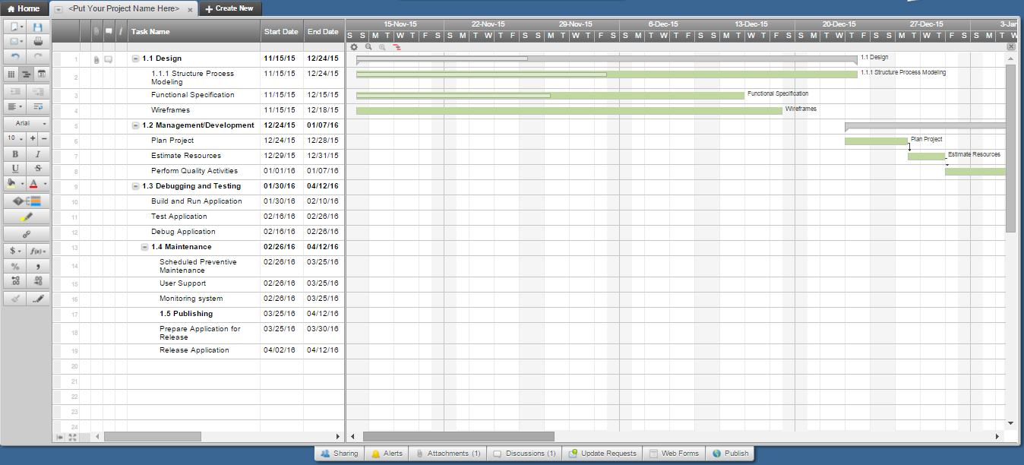

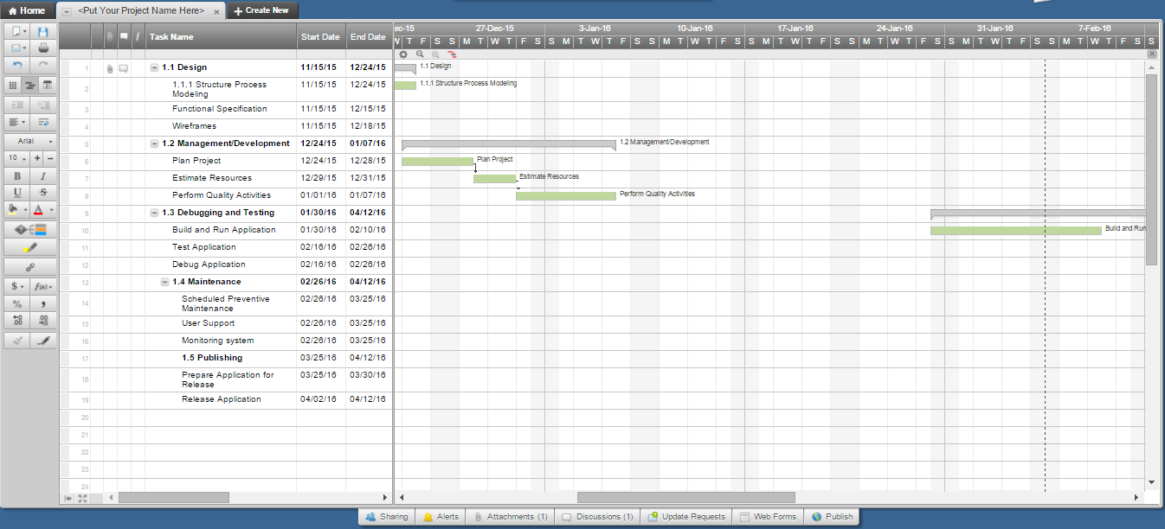

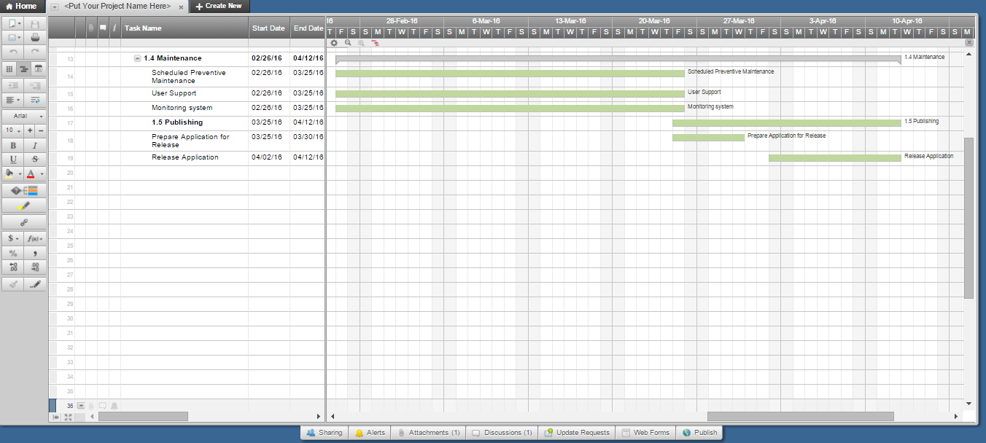

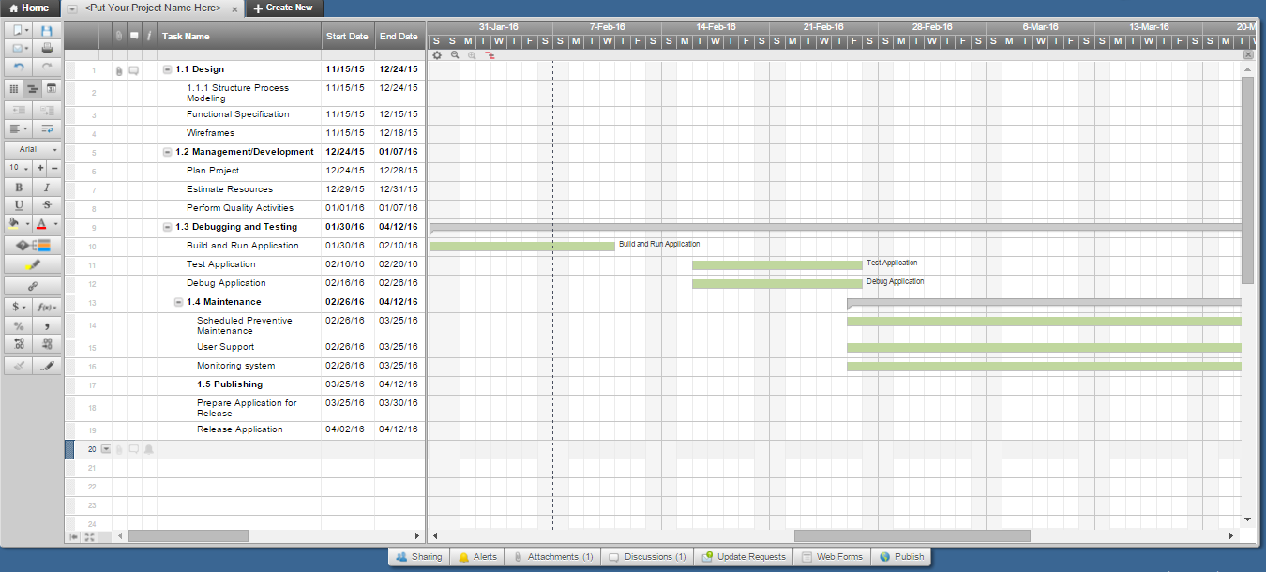

6. Work Breakdown Structure

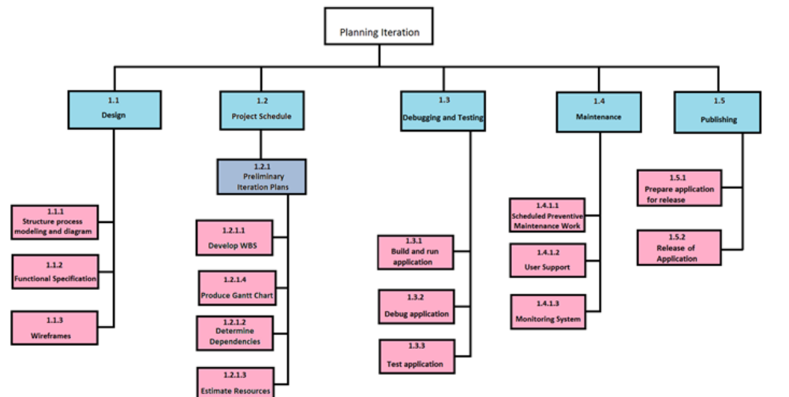

7. Activity List

Activity # | Activity Name | Activity Name Description | # of Days | Start Date | Dependency | Milestones
1 | Design | System Architecture | 35 | 11/15/15 |  | Detailed Design
2 | Develop | System Development | 40 | 12/24/15 | IFS | Software Code
2.1 | Code | Code - subroutine | 35 | 1/27/16
2.2 | Integrate | Integrate - subroutine | 25 | 1/27/16
3 | Testing and Debugging | Testing and debugging system | 21 | 1/30/16 |  | Completed accept test of documents
4 | Maintenance | Application Upgrades | 30 | 03/26/16 |  | Monitoring
4 | Publishing | Application Release | 30 | 04/2/16 |  | Final Release

